FRONTEND LOGIN

## Install react

* Install react router dom
* Axios
* Bulma
* Jwt-decode

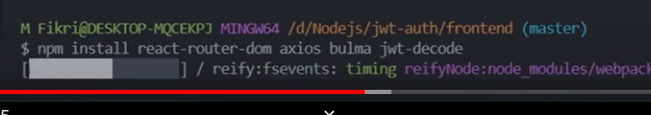

## Index.js

import React from 'react';

import ReactDOM from 'react-dom/client';

import App from './App';

import 'bulma/css/bulma.css';

import axios from 'axios';

// default  credential agar tdk perlu mengirim credential setiap req ke server

axios.defaults.withCredentials = true;

const root = ReactDOM.createRoot(document.getElementById('root'));

root.render(

  <React.StrictMode>

    <App />

  </React.StrictMode>

);

## Buat components / Login.js

import React from 'react';

import 'bulma/css/bulma.css';

const Login = () => {

  return (

    <section className="hero is-success is-fullheight">

      <div className="hero-body">

        <div className="container">

          <div className="columns is-centered">

            <div className="column is-4-dekstop">

              <form action="" className="box">

                <div className="field">

                  <label htmlFor="" className="label">

                    Email or username

                  </label>

                  <div className="controls">

                    <input type="text" className="input" placeholder="username" />

                  </div>

                </div>

                <div className="field">

                  <label htmlFor="" className="label">

                    Password

                  </label>

                  <div className="controls">

                    <input type="text" className="input" placeholder="*********" />

                  </div>

                </div>

                <div className="field">

                  <button className="button is-success is-fullwidth">Login</button>

                </div>

              </form>

            </div>

          </div>

        </div>

      </div>

    </section>

  );

};

export default Login;

import di App.js

import React from 'react';

import Login from './components/Login';

import { BrowserRouter, Routes, Route } from 'react-router-dom';

import Register from './components/Register';

function App() {

  return (

    <BrowserRouter>

      <Routes>

        <Route exact path="/" element={<Login />} />

        <Route path="/register" element={<Register />} />

      </Routes>

    </BrowserRouter>

  );

}

export default App;

buat components/Dashboard.js